Digital Financial Services (DFS) Toolkit for Financial Institutions
Accion Digital Solutions
September 2016

What is it?
Utilizing a foundation of decades of experience in designing and implementing digital financial services around the world, Accion’s Digital Solutions team has created a simple DFS Toolkit for Financial Institutions.
The Toolkit aims to support Financial Institutions (FIs) to properly plan, pilot, roll-out, and operate scalable and effective digital delivery channels, such as mobile banking, mobile point of sale, agent banking and other forms of branchless banking. Embedded within are best practices, key activities, tools, and components that should be in place in order to allow digital financial services (DFS) to thrive and scale. The approach is designed to help organisations remain agile, facilitating continuous improvements as monitoring and evaluation insights inform necessary adjustments.
By sharing the best practices, tools and guidelines we’ve developed, we hope to advance industry knowledge to facilitate future development and usage of digital financial services.

How is it used?
The DFS Toolkit for Financial Institutions is applicable but not limited to two main use cases:
- The planning and implementation of new DFS delivery channels
- The review of existing DFS channels as a way to revisit certain steps and diagnose areas for improvement
In each case the Toolkit defines a structured approach, which is universally applicable across all DFS channels.

Structure of the DFS Toolkit for Financial Institutions
The structure of the Toolkit consists of 8 components comprising a high-level process flow for the planning and implementation of DFS channels. Underpinning each component is a requirement to constantly assess and review potential risks, taking action where appropriate. Figure 1 describes the structure of the DFS Toolkit for FIs, illustrating that each stage is secured by risk assessment.
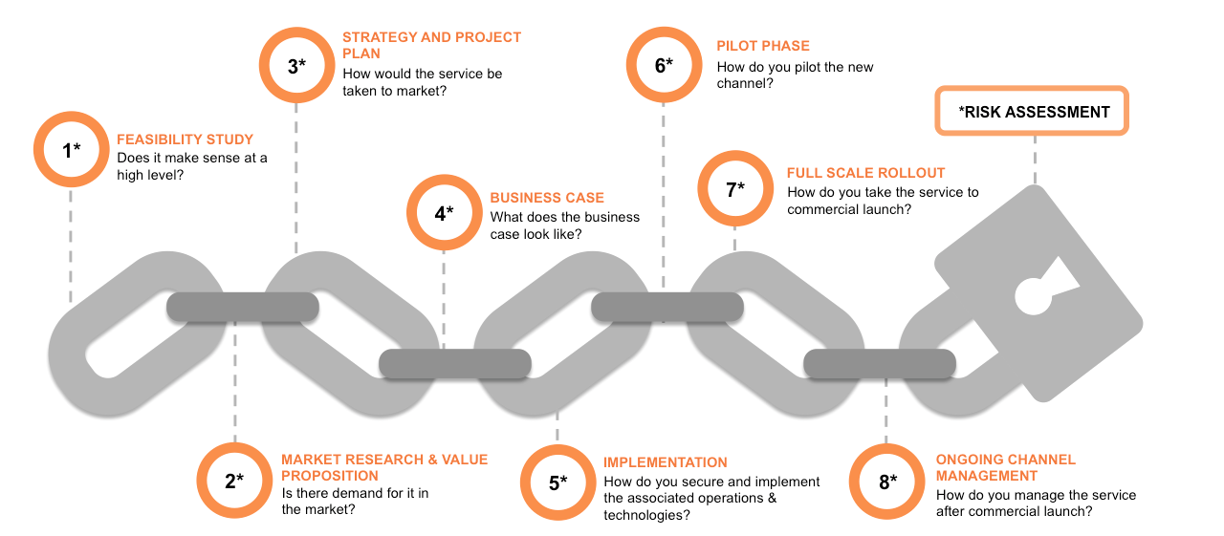

Figure 1: Structure of the DFS Toolkit for Financial Institutions

Understanding the Components of the DFS Toolkit for Financial Institutions
Each of the Toolkit components can be categorized as either planning or implementation stages as defined below. Figure 2 identifies subcomponents within each.
Planning: When deploying digital channels, a brief feasibility study is the first step in gaining a good understanding of what is possible and the potential for success, considering your market environment, institution and target clients. It will also provide a clear path and help with decision making and planning. This is followed by deeper market research and finalizing the value proposition, strategy, project planning and business case. Collectively, these steps can all be considered part of the planning phase.
Implementation: Execution of the plan comprises operational and technical implementation, pilot and roll-out phases, and ongoing channel management, with activities related to process, technology and communications, training, marketing, customer service, and monitoring.
Throughout the deployment of a channel, risks should be identified, assessed, and mitigated. Figure 2 provides a high level summary/checklist of the components of the DFS Toolkit for Financial Institutions:

PLAN
Feasibility Study
Draft Project Charter

Conduct an External Analysis of the market environment

Conduct an Internal Analysis of the organization's readiness

Create High-Level Business Case

Present Overview of Feasibility Study Findings

Make Go/No-Go Decision and How to Go Decision

Market Research and Value Proposition
Identify and size the target market

Perform market segmentation

Perform demand-side research (including customer behavior and needs)

Learn from the results and translate into services/products

Conduct concept testing for value proposition and product(s)

Strategy & Project Plan
Define the priority and timeframe of objectives from the project charter draft

Define impact metrics (KPIs)

Define customer outreach/acquisition strategy

Identify business requirements

Identify partners and strategy. Define partnership scenarios and value proposition

Develop project management approach

Define market strategy

Map financial products (new and existing) to channel(s)

Finalize partners and engagement strategy

Finalize project charter

Consolidate and refine the high-level business case

Assess the business case and Develop financial model
Define assumptions and scenarios

Identify payment and pricing models

Define cost inputs

Identify cost savings

Confirm potential revenue streams

Calculate potential savings

Perform total cost/benefit analysis for the pilot and if possible roll-out phase
IMPLEMENT
Implement Channel (Technical / Operational)
Review and develop processes, procedures and policies (including agent network,
segregation of duties and customer service).

ICT: Define / Refine overall project plan and functional specifications

Define technical specifications

Training and Education planning

Call center and helpdesk support

Define disaster recovery and business continuity plans

Marketing plan development

Measurement and impact planning

Development and Testing

Pilot Phase
Define pilot plan

Perform pilot staff training and client education activities

Define metrics that will measure pilot objectives

Execute marketing activities

Launch pilot

Monitor and evaluate Pilot

Make Go/No Go Decision

Full Scale Rollout
Define rollout approach and strategy and address issues identified during pilot

Perform staff training

Implement full scale helpdesk and call center support

Implement full scale marketing plan

Implement monitoring and evaluation plan

Ongoing Channel Management
Perform regular monitoring, focus on driving customer adoption

Assess customer experience

Conduct on-going staff training

Conduct further market research (e.g., customer satisfaction surveys)

Perform further marketing activities

Perform ongoing customer education

Adjust service as necessary (functionalities, pricing, support, offering)

Risk Assessment
DFS risk review

Operational risks

Financial risks

Reputational risks

Technology risks

Regulatory risks

Other risks

Figure 2: Components of the DFS Toolkit
DFS Toolkit for Financial Institutions: Guidelines and Templates
Accompanying each component are tools, guidelines, templates and best practices specifically engineered to assist in the execution of associated tasks. These tools, templates and guidelines are designed to be customized appropriately to the dynamics of each individual implementation.

